Starting with Charlie, I’m going to run through weeks 1-3. Week 3 is apparently difficult, so I’ll have to save a lot there

Saved Day 2 week 1 so I can come back to it and focus on each route from there. This way I can have points, but not worry about having less than max points on each run (page 5 save 2)

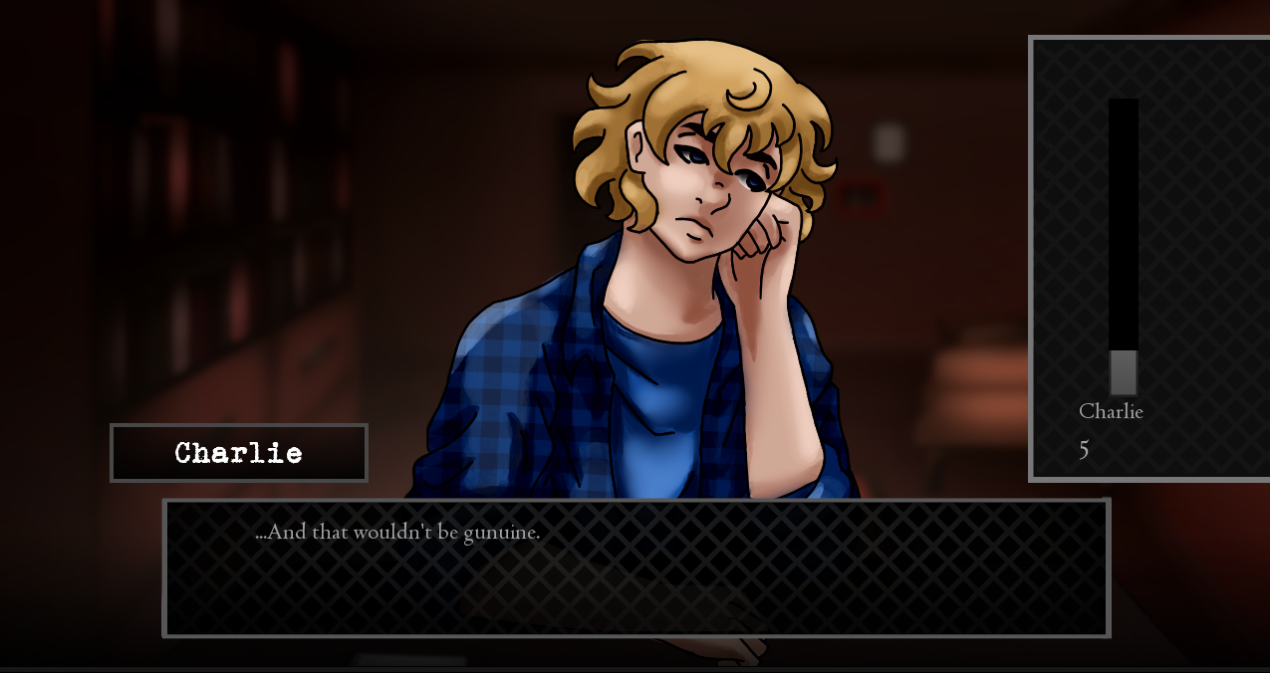

Charlie day 2 week 1. I’m not sure how I missed this every time. “Genuine” instead of “gunuine”

Onto day 4 week 1

From Sue’s second event. “neighbors” instead of “neighbours”

Interesting. This came after saying “no” to taking notes on William’s second? Session, day 4 week 1

Same thing happened after Michael’s session on Friday, session 2 of 2 week 1

Ended week 1 of Charlie’s route with 19 points with him

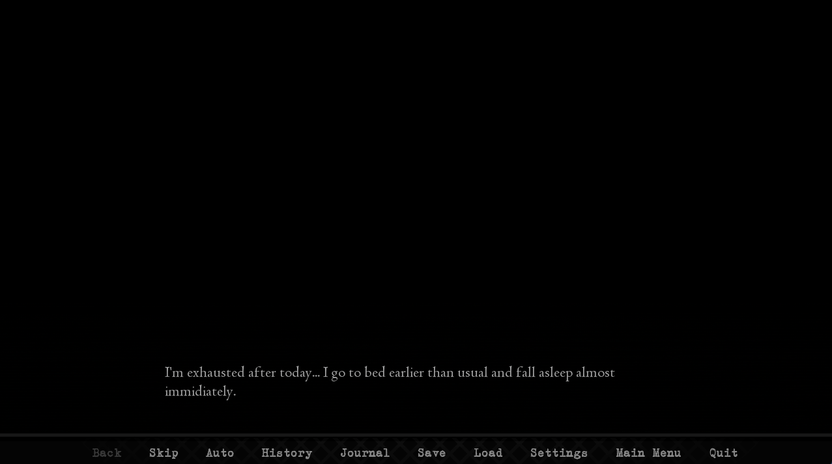

From the end of week 1 after the last interview and going home

From Charlie’s dream, several different bugs. The rest are immediately below.

This next one seems related to the investigation, for some reason appearing on Sunday, then again on Monday

Another undefined variable to do with the investigation, after session 2 day 1 week 2

Is this dream sequence supposed to be in week 2? I don’t remember it on my last two runs. Maybe it’s a different graphic or just my bad memory

Milena undefined again on day 2 week 2

Exception on line 591 in the engine again after session 2 day 2 week 2

So this is a complaint that might be specific to the engine itself, but now every time I load a game save, it sends me to the “save” screen instead of either keeping me on the “load” screen or sending me to the game screen. It’s pretty frustrating.

So this is an opinion more than anything, but the first exploration event (to pick up a map of the hospital) I think should be automatic at some point, so no one has to do that to unlock more exploration events. This is relevant to Charlie’s route and maybe some other points in the game, because without exploration and knowing the building layout, or exploring with Sue, MC doesn’t have much reason to know where the activity room is (Charlie week 2 day 3? Drawing the forest map) unless it can be assumed she explored offscreen.

I forced the Dr. Young scene by reloading saves, and I think it’s worth mentioning that it’s inconsistent that only he has the screen saying, “you feel a bond forming.” Though it’s not necessarily bad, that could just be a one-off thing.

Woah, the fight at the end of week 2 on Charlie’s route?

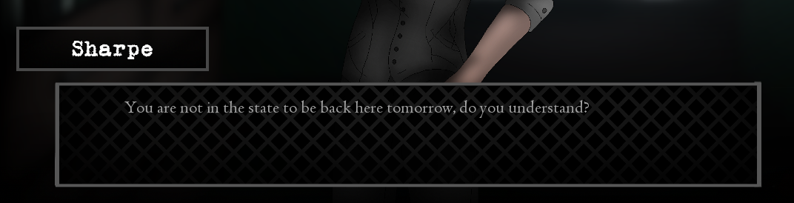

But in this case it’s a Friday, she wouldn’t come in on Saturday

Okay, somehow I got a bad ending for week 2 Charlie’s route

Old sprite on week 2 day 5

Between Friday week 2 and Saturday a dream just doesn’t occur, but MC talks about some girl in a dream

Should be “none of us are”

She showed it to me, she betrayed you, I’m the one trying to help you?

Friday week 2 break, apparently this shouldn’t happen

Thursday week 3

Friday week 3 I think, after the attack

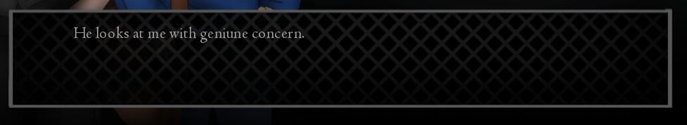

Same scene, should be “genuine”

**UMMM**

Still tells me to come back Monday instead of tomorrow, but tomorrow is still Friday. Maybe saying “two days” would make it less weird, because even in other situations I think the attack happens on a Wednesday, making returning Friday make sense? Oh, it was Thursday

Sharpe disappears at the phrase “He glances at the time”

Finally on Week 4, Saturday

I think the Sue visit happened even though I said I was too tired? It happened on Monday

I invited Dr. Young but not Sue, she came anyways

JULIA SHOWED UP AFTER COFFEE ON HER OWN, no announcement, no entrance

Reloading and deciding not to invite Young fixed Monday I think, but also I thought she was supposed to go back to work on Monday?

It skipped Tuesday and went to Wednesday. Like as in, showed Tuesday’s screen, then showed Wednesday’s

So the memories and dreams are really good, but I wish there was a stronger signifier that one or the other started. I think I personally can tell, but they’re really starting to get muddled in week 4 since they’re happening so often.

Oh okay. So she was scheduled to come back not this Monday but *next* Monday

End of Build C, at least for Charlie. That was heavy.